Test Plan

Test Series and number | Purpose | Test Data | Expected Result | Actual Result | Evidence in appendix
1.1 | Navigate between tabs correctly | Click on tabs | Viewport changes to clicked on tab | Viewport changes | See 1.1
1.2 | 'New Appointment' dialogue shows when requested | Click on 'New Appointment' button | 'New Appointment' window is shown | 'New Appointment' window is shown | See 1.2
1.3 | 'Respond to meeting request' dialogue shows when requested | Click on 'Respond to meeting requests' | 'Respond to meeting requests' dialogue is shown | 'Respond to meeting requests' dialogue is shown | See 1.3
1.4 | 'Add new task' dialogue shown when requested | Click on 'Add new Task' button | 'Add new task' dialogue box shown | 'Add new task' dialogue box shown | See 1.4
2.1 | Validate Username & Password entry | Username:”p”, password: “hello” (correct) (normal data) | Login window closes and main screen is shown | As Expected | See 2.1.1-2.2.3
2.1 | Validate Username & Password entry | Username: “f”, password: “rfskbkb” (incorrect) (erroneous data) | Error dialogue is shown, user is returned to the login screen. | As Expected | See 2.1.1-2.2.3
2.1 | Validate Username & Password entry | Username: inion...”(part of a 1024 character string), password: “skljnsjns...”(part of a 1024 character string)(extreme data) | Error dialogue is shown, user is returned to the login screen. | As Expected | See 2.1.1-2.2.3
2.2 | Validate New Password – current password | “hello” - correct password  (normal data) | Form submits (assuming it passes the other checks) | As Expected | See 2.2.1
2.2 | Validate New Password – current password | “goodbye” - incorrect password  (erroneous data) | Warning is shown and form does not submit | As Expected | 2.2.2
2.3 | Validate the two new passwords | “goodbye” and “goodbye” entered – passwords match  (normal data) | The form submits (assuming the data passes all other checks) | As Expected | 2.3.1
2.3 | Validate the two new passwords | “goodbye” and “marmaduke” - passwords to not match  (erroneous data) | A warning is shown and the form does not submit | As Expected | 2.3.2
2.4 | Validate the new task name | “soibsfsbse” - string of characters less than 45 in length  (Normal data) | The form submits and the user is allowed to continue | As Expected | 2.4.1
2.4 | Validate the new task name | “rslskkubsilesbslob…” - string of characters 50 in length  (erroneous & extreme data) | The form truncates the string at 45 characters and continues as normal | As Expected | 2.4.2
2.5 | Validate attendees in new meeting | “sv” - a valid username  (normal data) | The form submits, assuming it passes other checks | As Expected | 2.5.1
2.5 | Validate attendees in new meeting | “ubhsbwhiu” - an invalid username  (erroneous data) | The form submits, but does not include the invalid data | As Expected | 2.5.2
2.5 | Validate attendees in new meeting | “sv, p” - a list of valid usernames  (normal data) | The from submits the data – one entry to the Meetings table and one entry for the each of the usernames in the MeetingAttendee table. | As Expected | 2.5.3
2.5 | Validate attendees in new meeting | “sv, p, esflkjbsjh b” - a list with some correct and some invalid values  (normal & erroneous data) | The form submits the meeting data to the Meetings Table and adds attendance data for each of the correct usernames. | As Expected | 2.5.4
2.5 | Validate attendees in new meeting | “kjsb, 3ijbalij, aekjbslkj” - A list of invalid usernames  (erroneous data) | Meeting data submitted to database, attendees are ignored | As Expected | 2.5.5
3.1 | Check that the list of resources is loaded correctly | Open the Resources view | All of the resources listed in the database should be displayed | As Expected | 3.2
3.2 | Check that the list of meetings loaded correctly | Open the meetings view | All the meetings for that specific user should be present | As Expected | 1.1
3.3 | Check that the list of tasks loads correctly | Open the tasks view | All the tasks for the current user should be present | As Expected | 3.1.0
3.4 | Check that the list of attendance requests loads correctly | Open the “Respond to meeting requests” dialogue | All the meetings that user has been requested to attend should be listed | As Expected | 3.4
3.5 | Check that the correct user's name is displayed in the user admin area. | Open the user admin area. | The current user's name (the user used for testing is called 'Dick') should be shown at the top of the screen | As Expected | 3.3
4.1.1 | Check that the Meeting data is stored to the correct table | AddNewMeeting – fill form with valid data | The data should be inserted into the Meetings Table in the database. | As Expected | 2.5.1
4.1.2 | Check that the attendees data is stored into the correct table | AddNewMeeting – with a list of valid attendees | Each of the attendees should be stored in the MeetingAttendee table with the corresponding meetingID | As Expected | 2.5.3
4.3 | Check that the Task data is stored in the correct table | AddNewTask – fill form with valid data and submit | The data should be inserted into the Tasks table | As Expected | 4.1
4.4 | Check that the updated password data is stored in the correct table | UpdatePassword – fill form with valid data and submit | The database should update the correct table and update the correct record | As Expected | 4.2

Test Series | Purpose of test series
1 | Test the flow of control: Menu choices linked to correct interfaces. User can only choose the correct choices.
2 | Validation of data input performed correctly.
3 | Test that the dynamic aspects of the software are loaded correctly from the database.
4 | Data is saved into the correct table, fields or files.

Testing Evidence

1.1
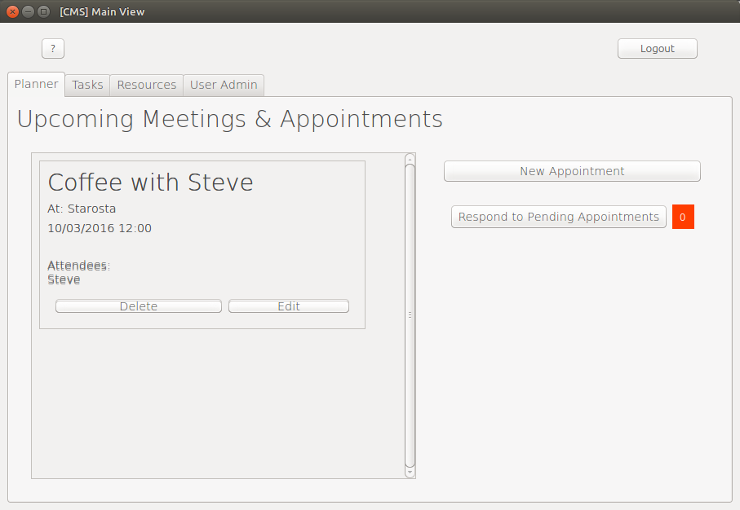

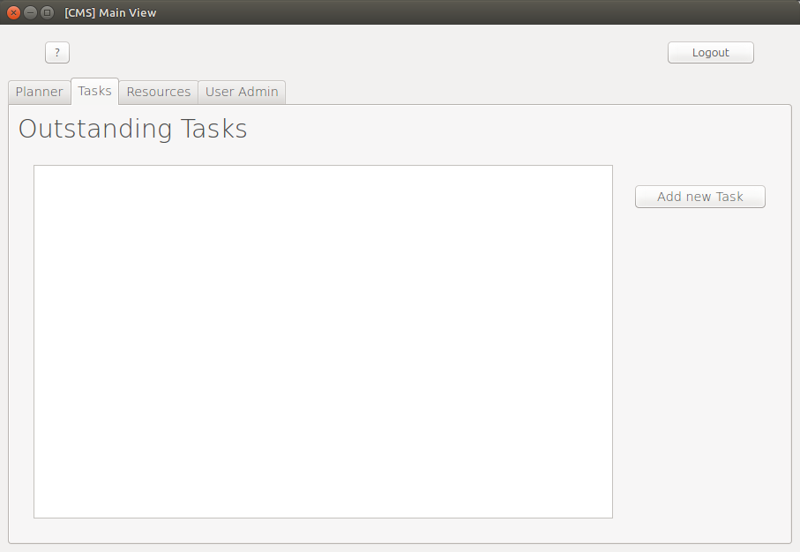

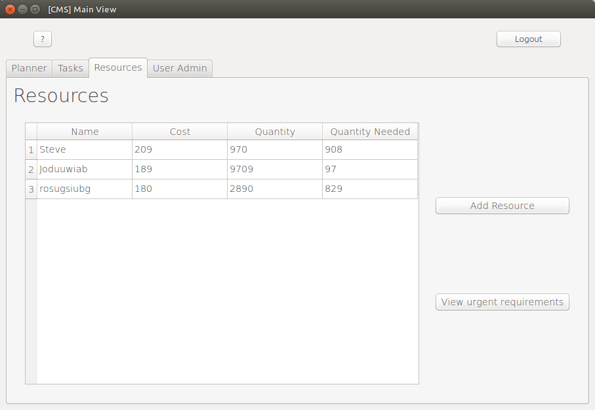

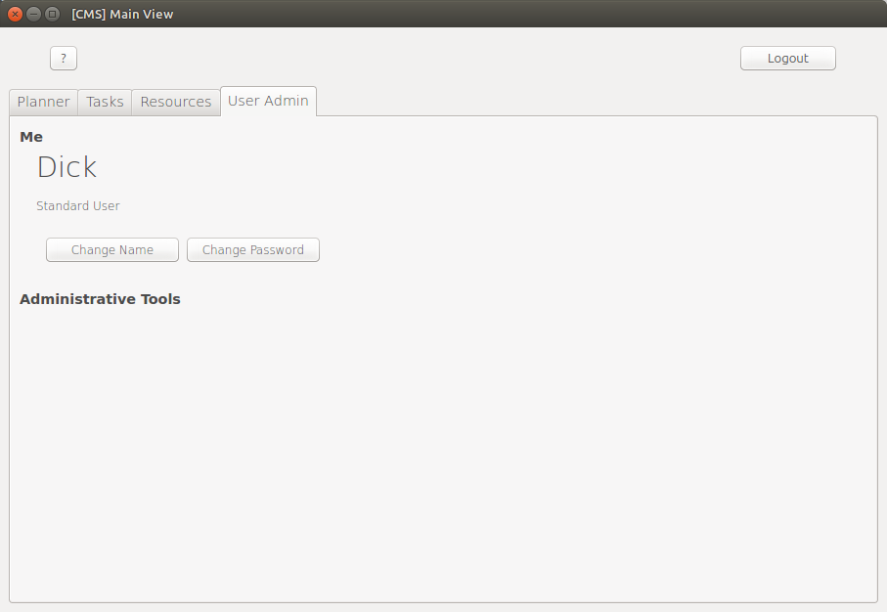
The tab changes when clicked.

1.2
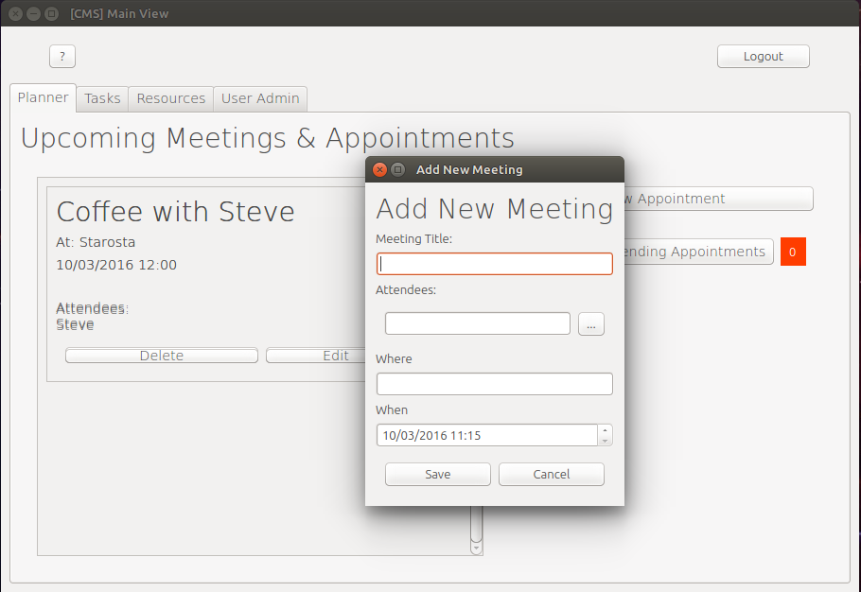

1.3
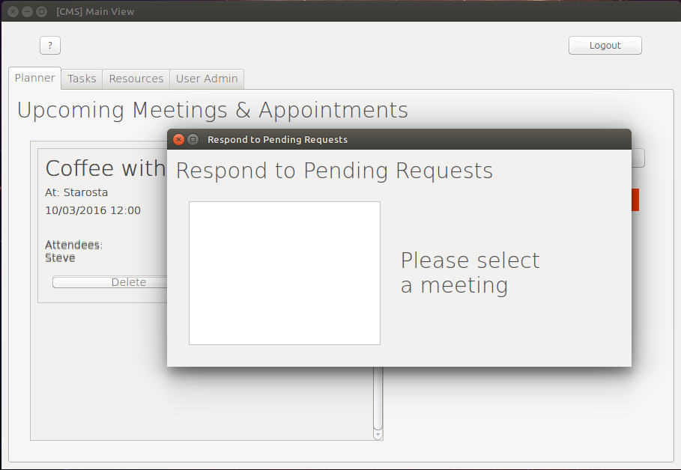

1.4
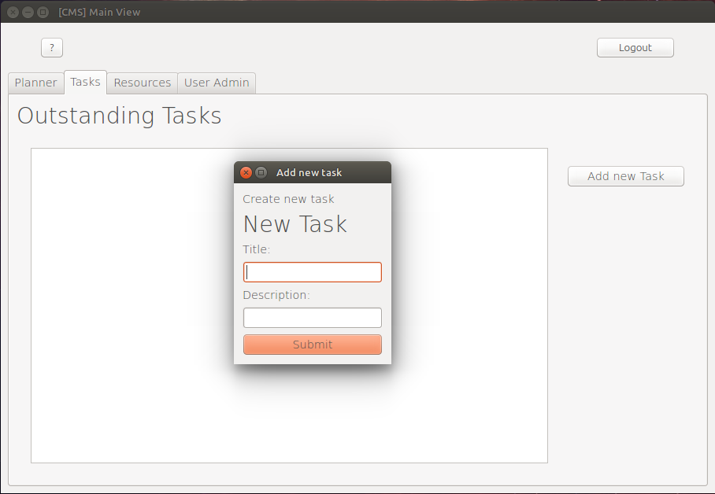
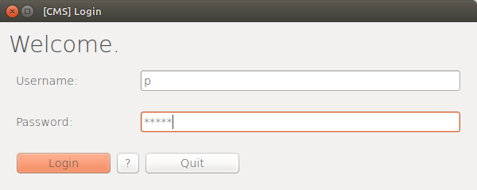

2.1.1
Input text:
Username: “p”
Password: “hello”
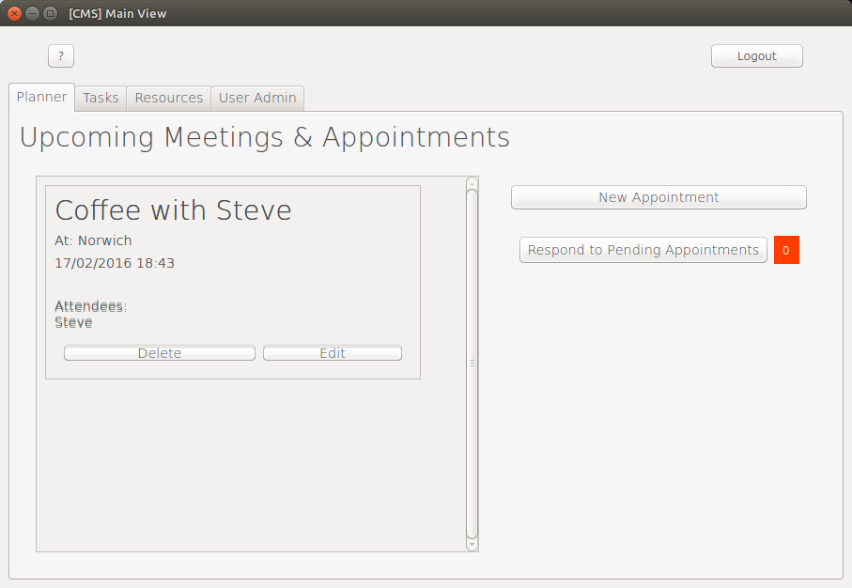

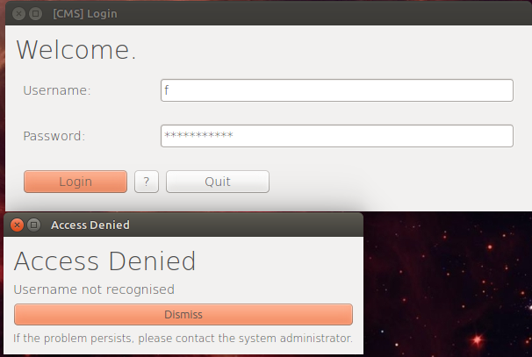
2.1.2

2.1.3
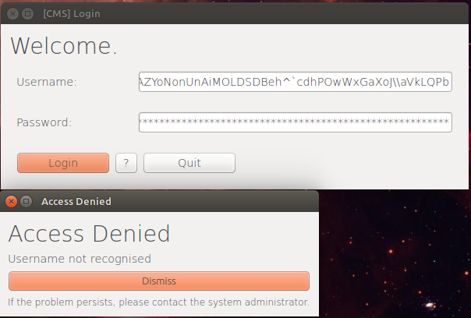

2.2.1
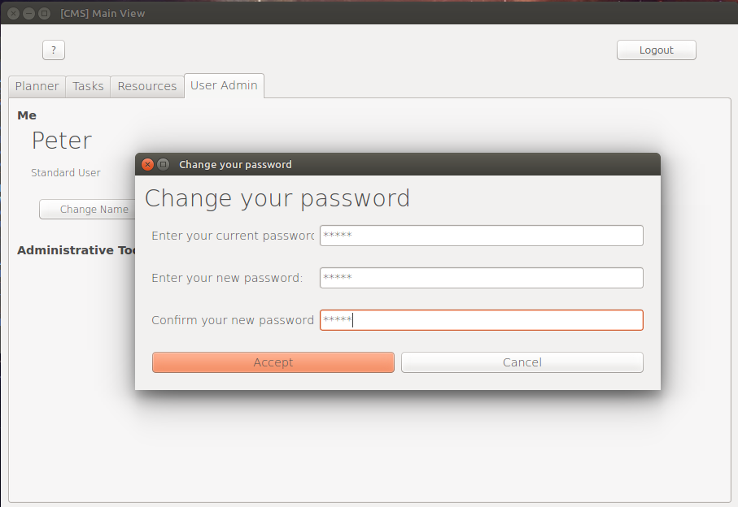
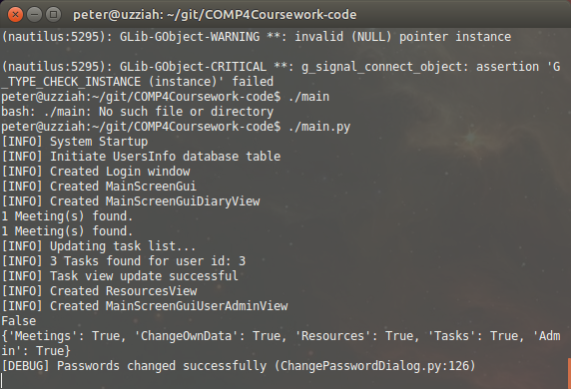

2.2.2
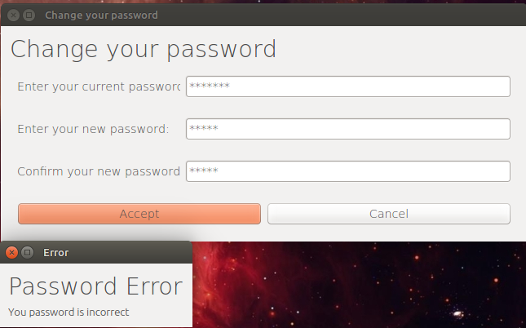

2.3.1
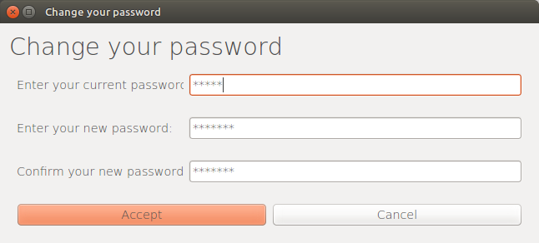
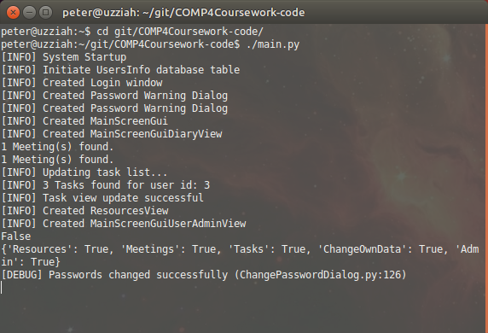

2.3.2
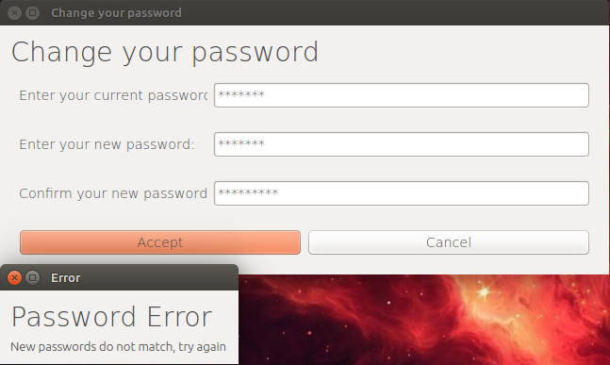

2.4.1
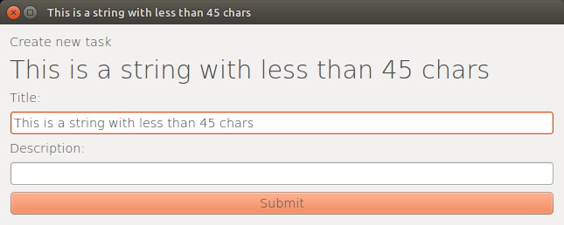

2.4.2
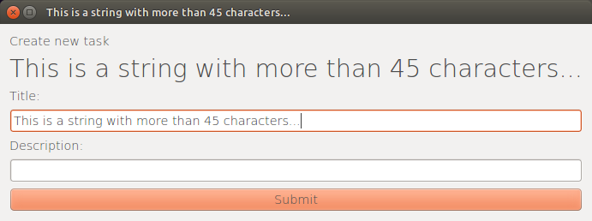

2.5.1

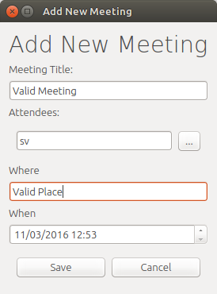

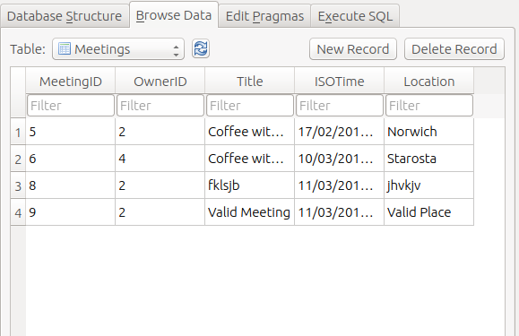
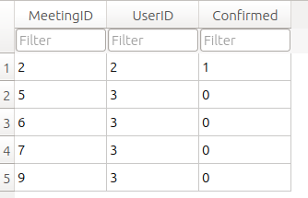

(user 'sv' has the userID of 3) This whows that the correct meeting and user are assiciated.

2.5.2
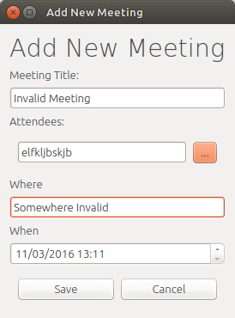

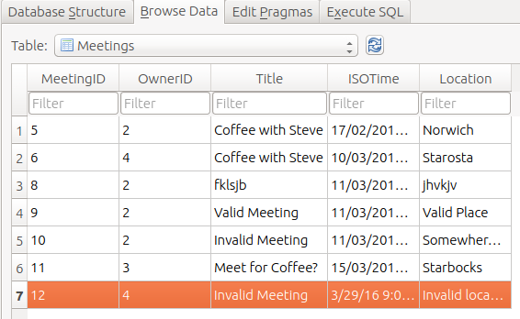

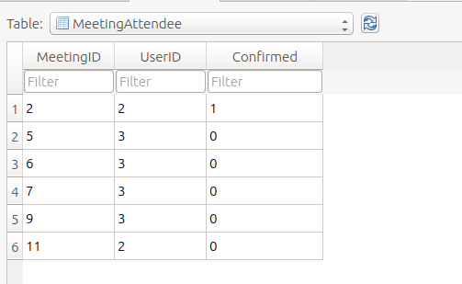

Notice that the meeting with ID=12 was stored, but not added to the list of meeting attendees.

2.5.3
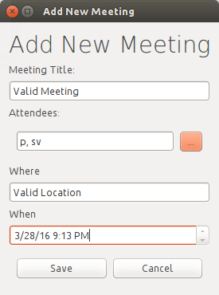

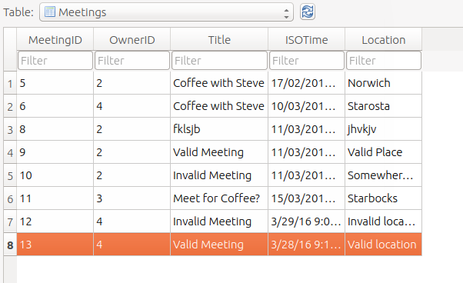
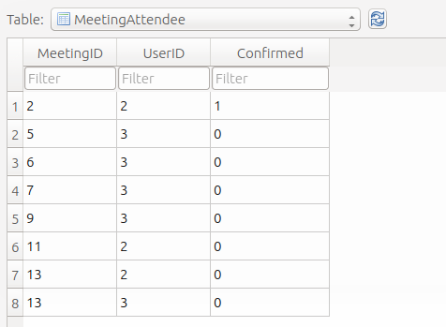
Note the two users listed for the meeting (MeetingID=13)

3.1.0
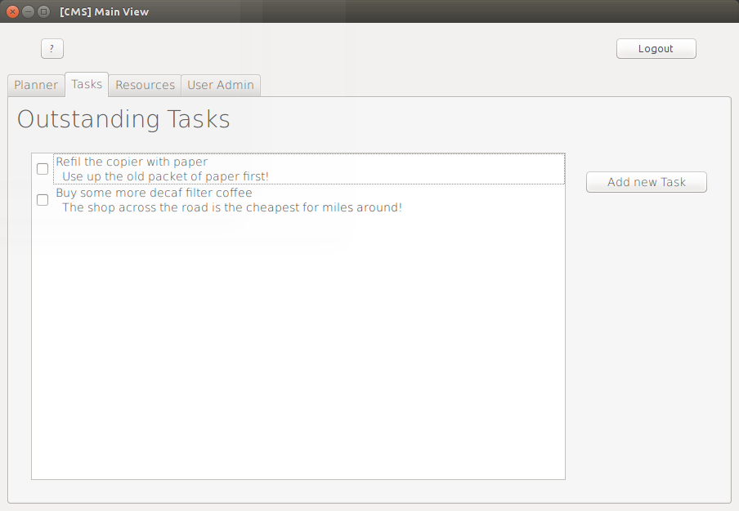
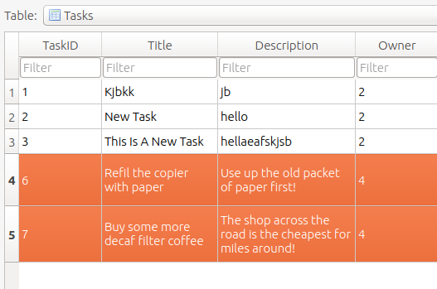
(Note: the testing user has a UserID of 4)

3.2
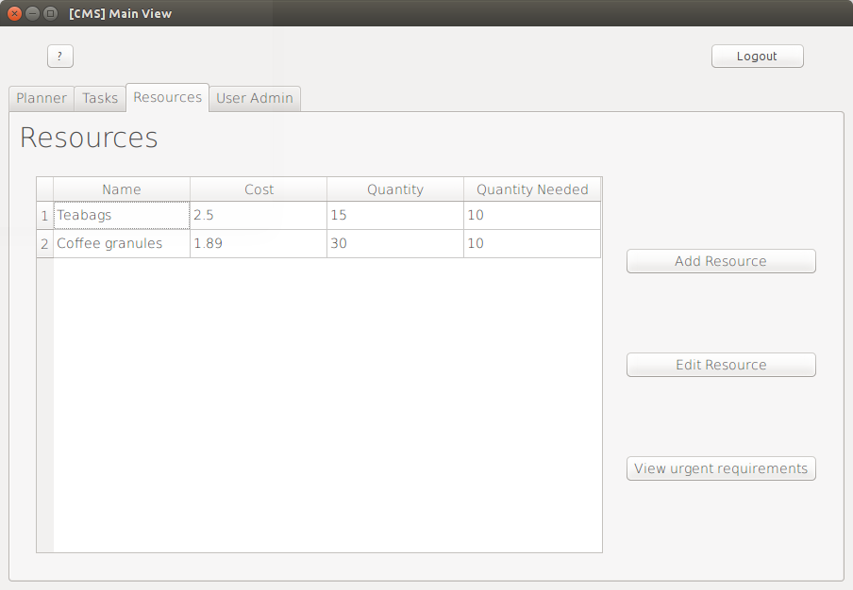
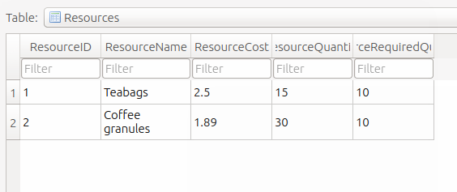

3.3
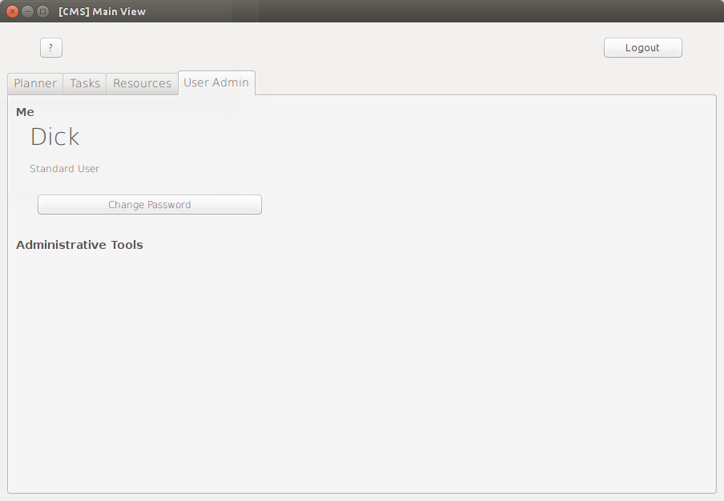
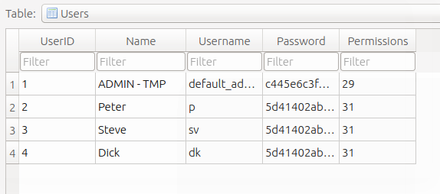

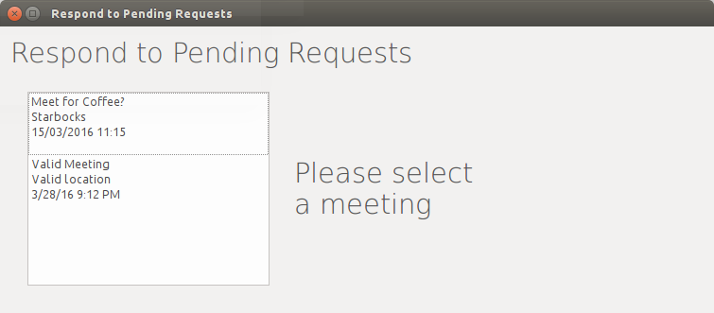
3.4

4.1
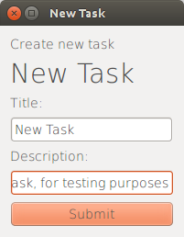
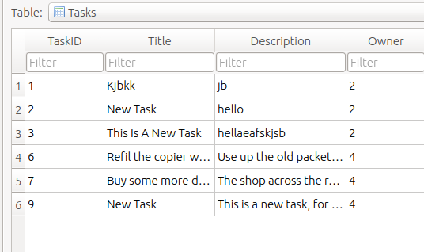

4.2
Before
After changing password:

